Live A Live HD-2D Remake Board Game
Translated Rulebook & Action Cards
Game Objective 2
Included 2
Game Setup 3
Example Setup 3
Party Drafting Phase 3
Battle Phase 5
Card Setup 5
How Action Cards Work 6
How Movement Cards Work 7
Turns 7
- Moving 7
- Attacking 8
- Charge Gauge 9
- End of Turn 9
When a character gets knocked out 10
Game End 10
Keywords 10
Interrupt 10
Pushback 10
Debuff 11
Linear 11
Action Card Examples 12
Sundown’s Hurricane 12
Oboromaru’s Death Blossom 13
Cube’s Maser Cannon 13
Credits 13
Character Action Cards 14

Players: 2
Age: 10+
Playtime: 30mins

Live A Live HD-2D Remake Board Game

A 1 versus 1 board game that borrows mechanics from the Live-A-Live! video game. Pick 4 characters
and duel it out with another player!

Game Objective

Each player forms a team of 4 characters that will battle an opposing group with their own team of 4 characters. The first player to knockout two characters on the opposing side wins!

Included

1 Battleﬁeld  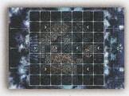 | 8 Character Pieces  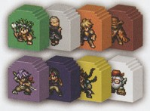 | 8 Character Tiles  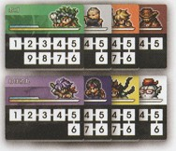
26 Action Cards
(3 cards x 8 characters 2 movement cards)

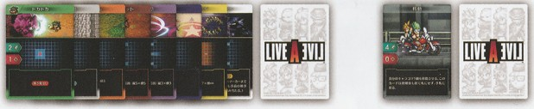

6 Target Tokens  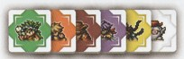  ※ Masaru and the Earthen Heart Shifu don’t have target tokens | 6 Debuff Tokens  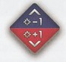 | 8 HP Counters  6 Charge Counters  1 Rulebook

Game Setup

1) Place the board on the center of the table.
2) Give each player 1 movement card and 4 HP counters.
3) Set the character pieces aside along with their corresponding action cards (indicated by color).
4) Shuffle the character tiles and stack them face down.
5) Set the charge counters, target tokens and debuff tokens into 3 separate piles.
6) Determine the player who goes first.

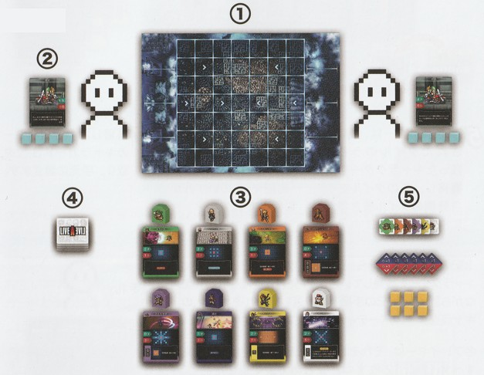
Example Setup

Party Drafting Phase

Follow these steps to determine which characters each player will use during the game.

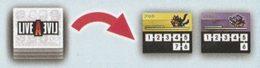

- The first player draws 2 character tiles and turns
them face up.

2. The first player chooses one character tile and places it on the side of the game board nearest to them and… | 3. …Then place the corresponding character piece on a starting square, indicated by a white arrowhead symbol. | 4. Take the character’s corresponding 3 action cards, denoted by color.  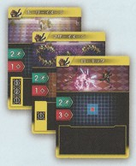
Starting Squares

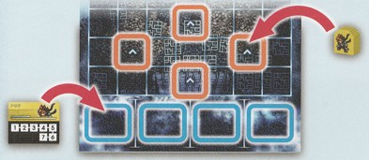

5. The Second player takes the remaining character tile and repeating steps 2-4.

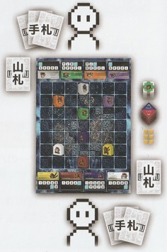

Repeat steps 1-5 but this time alternating which player chooses the character tile first, until each player have a party of 4 characters each. After this each player should have 12 action cards.

Shuffle the 12 action cards to create a facedown deck and draw 4 cards. After this add 1 movement card to your initial hand. You then should now have a starting hand of 5 cards, which is kept secret to the other player.

Lastly, place the HP counter on the highest HP value on each character tile. And that's the setup! We now move on to the Battle Phase.

手札 = Hand / 山札 = Deck

Battle Phase

The player who went first during the drafting phase will now get to act first. During the Battle Phase players plan what their characters are going to do with the use of their ACTION CARDS, taking turns using each card in a certain order. This process is called a round. Repeat each round with the players alternating who goes ﬁrst and who goes second until one of them wins.

The ﬂow of a round goes like this:

- Card setup
- Player one’s ﬁrst turn
- Player two’s ﬁrst turn
- Player one’s second turn
- Player two’s second turn
- Player one’s third turn*

The first player to act gets an extra turn (Step 6). After reaching Step 6, the round is over.
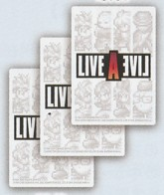
Last
The first player to act selects 3 action cards from their hand. The second player selects 2 action cards from their hand.

From their selected action cards, they need to make a facedown pile that will indicate the timing on which cards will be resolve first, second and/or last during a round. This means that the top card in the stack will resolve first, and so on.

First

Card Setup

How Action Cards Work
Action cards are unique to each character. When using an action card, the respective character can move and attack.
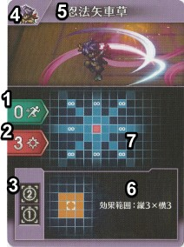
1. Movement
The number of tiles the character can move
2. Damage
The number of damage dealt to an opponent's character
3. Charge Gauge
Indicates the number of turns required until the skill resolves

4. Character
Which character uses the skill
5. Skill Name
6. Card Effects
Additional information or effect for the skill card

7. Skill Map
Where it shows the range of the skill. The map is oriented with the opponent’s side on the top area of the card, and the player's side on the bottom part.

Red square  Indicates where the character is standing. | Orange squares: Area of Effect (AoE)  Indicates that the skill or effect will resolve on all the squares highlighted in orange. Any number of opponents standing within the highlighted orange square will take damage or resolve certain effects.
Blue squares: Range

Indicates the range where a skill's
target can resolve.

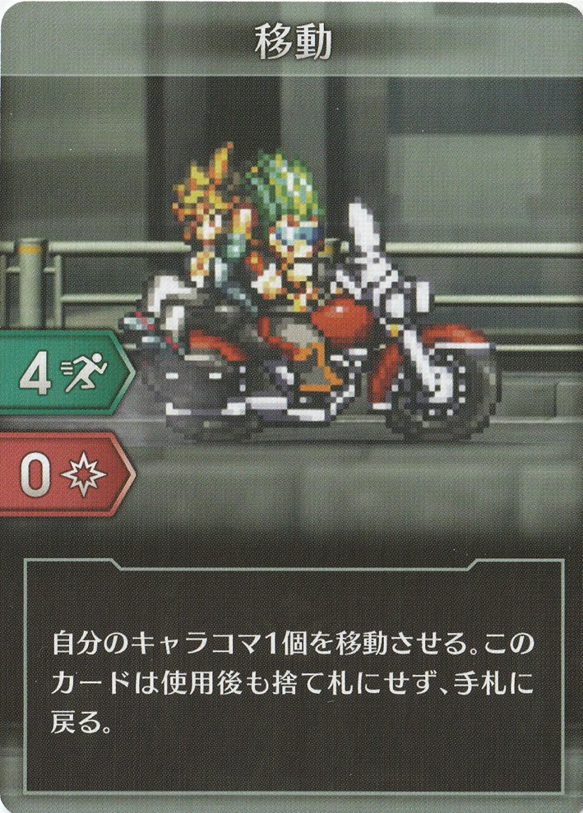
How Movement Cards Work

The "Movement Card" can allow one character to move up to 4 squares.
After resolving the action, the card goes back to the player's hand and does
not get discarded. This card can then be used again in succeeding rounds.

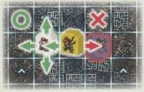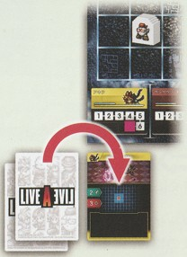Turns

A player’s turn begins by revealing the top action card and placing it below the corresponding character tile on the controlling player’s side of the board. You then resolve the card in order – starting from (1) MOVING, then (2) ATTACKING and, if indicated, placing a (3) charge counter on the CHARGE GUAGE.

※ IMPORTANT! – If there is already an action card below the character tile, then the player cannot resolve the card and instead discarding it and drawing another card from their deck. Alternatively, the player cannot also resolve an action card if the HP is 0.

Moving – Before attacking or using a skill, the character may move based on the indicated movement value (green, left side of card). Moving can be made by going up, down, left or right in the board, to move in a diagonal manner, 2 movement points are used (for example, right-up or left-down).
IMPORTANT! - Character pieces can't share on the
Same tile space. When moving, players can pass
through other characters that belong in their party.
They cannot pass through squares occupied
by characters belonging to the opponent.
Example: Akira can pass through Cube’s square since they’re in the same party. Akira can’t pass through Oboromaru’s square since Oboromaru is in the enemy party.

When a player uses a movement card, they can move up to 4 squares for as long as the characters is not charging up a skill.

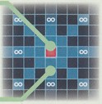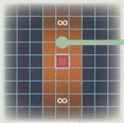Attacking
To attack, players select a square (or in some attacks, a number of squares) that indicates the attack's intended target. The red square in the middle represents where the attacker is. Some skills don't have range and instead targets the area around the character's square.
The red square is where the character is.

What happens next depends if their skill has a charge gauge or not.
The blue squares represent the skill’s targeting range.
For skills that activate around the character, there are no blue squares. Instead, it uses orange squares for its AoE, like shown on the left.

IF THERE IS NO CHARGE GAUGE = The attack resolves immediately. The enemy on the targeted square will take the damage indicated on the card. If the skill is an area of effect (AoE), then *all enemies within the AoE range will take the damage. Take note that some cards might have additional effect other than damage.

After the attack resolves, place the action card in a designated discard pile.

*Allies within the AoE range do not take damage or be affected by special effects on the card. The exception to this rule is Cube's Data Recovery, which restores HP to all allies within the AoE.

IF THERE IS A CHARGE GAUGE = The player places a TARGET TOKEN and the attack will resolve after the player takes the number of turns indicated by the by the gauge value on the card. If the attack has no range, place the target token on the square of the character using the skill.

Cards with CHARGE GAUGES aren't discarded until after the attack resolves (or interrupted).

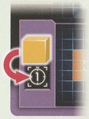Charge Gauge
Here are instructions on how to manage action cards that have a charge gauge. If multiple action cards have charge gauges in them, they can manage this in any order.

IF THERE IS NO CHARGE COUNTER (Card was played on the same turn)
= Place a charge counter on the highest value on the charge gauge.

WHEN THERE IS A CHARGE COUNTER ON THE CARD
= Move the charge counter to the next lowest number on the charge gauge
(For Example from 3 to 2, 2 to 1 etc).

WHEN THE CHARGE COUNTER IS ON 1
= Remove the charge counter and resolve the skill. The enemy on the square with the target token will take damage indicated on the action card, adjusting their HP values as necessary.

After the attack resolves, the player then removes the target token from the board and places the action card face up in their discard pile.

End of Turn
Once the player is done, their opponent will then take their turn.

Both players alternate in taking turns until they have used up all their preselected action cards, signaling the end of the round.

To begin the next round, both players draw 2 cards* from their deck and add them to their hand.

Turn initiative now swaps. The first player now goes second and vice-versa.

*If a player's deck runs out of cards, they will need to shuffle all the card in their discard pile to form a new deck and draw as they are owed. Movement cards always remain in the players hand and does not get discarded. This is a reminder to always add the movement cards back to the owner's hand after resolving them.

When a character gets knocked out

When a character's HP drops to 0, remove the corresponding character piece from the board. Then remove the HP counter, debuff tokens (if any) from their character tile, then turn the character tile face down. If there is an action card under the character tile, remove it from the game returning it to the box. Any charge counters on the card are returned to the general supply.
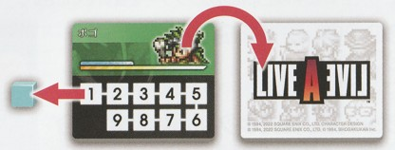

In addition, if a player has any action cards corresponding to the character that has been knocked out, remove those cards from the game (returning it to the box) and replace those cards by drawing the same number from their deck.

Game End

When one player has knocked out two of the other player’s characters, they’ve won and the game is over.

Keywords

Interrupt

A character who gets hit with interrupt will have their skill charge cancelled. Discard the interrupted action card that was below the character's tile, returning the charge counter to the general supply. Additionally remove the target token from the battlefield, if there was any.

Pushback

A character who is PUSHED must move 1 square. If they have an action card with a charge it is INTERRUPTED. Moved the attacked character piece 1 square away directly opposite from the attacking character's piece.

As with INTERRUPT, if a character action card has been placed under the character tile, discard the interrupted action card that was below the character's tile, returning the charge counter to the general supply. Additionally remove the target token from the battlefield, if there was any.

If there is nowhere to move the pushed character piece, then it can remain in the same square but the INTERRUPTED keyword still resolves.

Debuff

When a character is hit by a DEBUFF, put the corresponding Debuff token on their character tile. This indicates that the character's damage is reduced by -1 and the damage that they will take is increased by +1. A character can have more than 1 debuff token.

Linear

Skills that indicate LINEAR will ONLY hit the first character piece in their line of fire. They cannot hit multiple targets nor skip the first piece to hit the second one behind it.

Action Card Examples

Sundown’s Hurricane
Let’s say that Sundown is using Hurricane and puts the target token on “A” (ﬁg 1). After 3 turns, the skill has charged. With “A” as the center, the orange squares in ﬁg 2 show the AoE. Pogo, the only enemy character within the AoE, takes 4 damage.
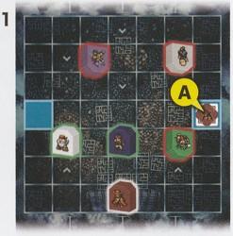
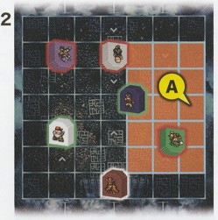

Oboromaru’s Death Blossom
Let’s say that Oboromaru is using Death Blossom and puts the target token on “B” (ﬁg 3). After 2 turns, the skill has charged. With “B” as the center, the orange squares in ﬁg 4 show the AoE. The two enemy characters in the AoE both take 3 damage.
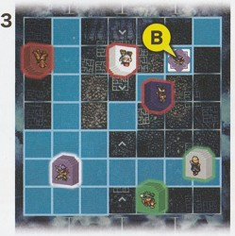
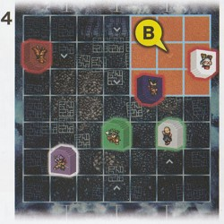

Cube’s Maser Cannon
Let’s say that Cube is using its Maser Cannon and puts the target token on “C” (ﬁg 5). After 2 turns, the skill has charged. The Shifu and Oboromaru are both in the skill’s line of ﬁre. However, Maser Cannon is a Linear skill that ﬁres from Cube towards the target token and only does damage to the ﬁrst enemy in its path. The skill hits the Shifu for 5 damage, but Oboromaru does not take damage because he’s on a square behind the Shifu (ﬁg 6).
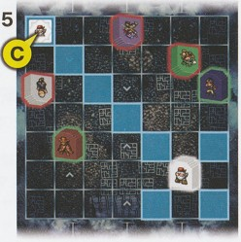
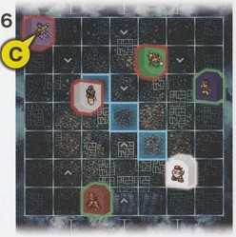

Credits
Board Game Rules: Yoshihiko Udo (Hobby Japan)
Board Game Production: Hobby Japan
Graphic Design: Makito Nakamura (Hobby Japan)
Japanese to English Translation: Anonymous
Scans: MarioFanaticXV
Revisions: Brian Papa (www.ungeek.ph)

Character Action Cards

Akira
Judgment Day | Low Kick | Mother’s Shame
Move: 2  Damage: 1  Charge: 3  AoE: ∞ height x 3 width  Keyword: Debuff | Move: 2  Damage: 3 | Move: 2  Damage: 1  Charge: 1  AoE: 7 height x ∞ width

Cube
Data Recovery | Maser Cannon | Spool Up
Move: 2  Damage: 0  AoE: 3 height x 3 width Effect: Restores 2 HP to self and all allies within the AoE | Move: 2  Damage: 5  Charge: 2  Keyword: Linear  (This skill will only hit the ﬁrst enemy character in the direction it’s aimed.) | Move: 1  Damage: 2  Keywords: Pushback, Linear

Masaru
Celestial Palm | Fleetfoot | Gale Strike
Move: 1  Damage: 1  Keyword: Debuff | Move: 1  Damage: 3 | Move: 1  Damage: 3

Oboromaru
Death Blossom | Phoenix Call | Shadow Slash
Move: 0  Damage: 3  Charge: 2  AoE: 3 height x 3 width | Move: 4  Damage: 2  Charge: 2  AoE: 5 height x ∞ width | Move: 5  Damage: 2

Oersted
Archon’s Mark | Heavenly Strike | Flourish
Move: 2  Damage: 4  Charge: 1  Keyword: Pushback | Move: 1  Damage: 3 | Move: 2  Damage: 1  AoE: 3 height x 3 width  Keyword: Pushback

Pogo
Bing Bang Boom | Fly Huge Boom | Pow Kick
Move: 1  Damage: 5  Effect: After using, inﬂicts self with Debuff | Move: 3  Damage: 4  Charge: 1  Effect: If there’s no enemy on the targeted square after the skill charges, Pogo does 3 damage to himself instead.  Keyword: Pushback | Move: 2  Damage: 1  Keyword: Pushback

Shifu
Chipmunk’s Delight | Heavenly Peaks Descent | Monkey’s Withdrawal
Move: 2  Damage: 1  Keyword: Interrupt | Move: 0  Damage: 4 | Move: 2  Damage: 2  Effect: After using, Shifu can move up to 3 squares

Sundown
Double Shot | Triple Shot | Hurricane
Move: 1  Damage: 2  Keyword: Linear | Move: 1  Damage: 3  Keyword: Linear | Move: 0  Damage: 4  Charge: 3  AoE: 5 height x 5 width

Movement

Move: 4
Damage: 0
Effect: Move a single character piece. After this card has been played, the player returns it to their hand.

Version History:

1.00 – Uploaded 25,08.2022
1.01 – Fixed some typo values for Shifu’s Chipmunk Delight and Sundown’s Triple Shot

